Usage Rate Correction Notification Form Guide

This guide will allow you to better understand the components provided in a Detailed Usage Rate Correction Notification Form. Listed below are descriptions for each section of the form:

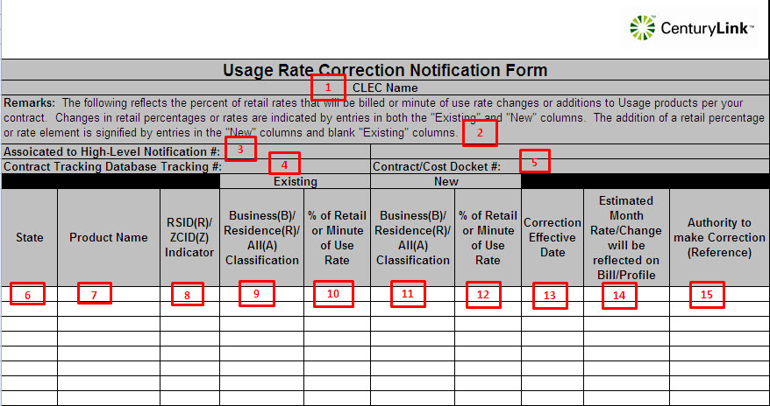

Detailed Usage Rate Notification Form Field Descriptions
- CLEC Name – This field will typically have the RSID/ZCID/CLEC ID and the CLEC Name
- Remarks – This field will contain summary information about the changes that are detailed in the fields below. “The following are Resale discount changes or additions of Resale discounts per your contract. Changes in discount percentages are indicated by entries in both the "Existing" and "New" columns. The addition of a Resale discount rate is signified by entries in the "New" column and blank "Existing" column. Resale discounts are represented below as a percent of retail.”
- Associated to High-Level Tracking # - This is a batch tracking number used to associate the High-Level Notification to this Detailed Rate Change Notification
- Contract Tracking Database Tracking # - This is a number used internally to identify this Notification with it’s entry in the Contract Tracking Database
- Contract/Cost Docket # - This is the contract or cost docket number that was used as the source for the changes detailed in the fields below
- State – State affected by change, changes related to multiple states may be included in a single Notification Form
- Product Name – Usage element name that is affected by change
- RSID(R)/ZCID(Z) Indicator – ‘R’ or ‘Z’ indicating the type of customer being affected by change
- Existing Business (B)/Residence(R)/All(A) Classification – Code indicating the type of usage being affected by change
- Existing % of Retail or Minute of Use Rate – % of Retail or Minute of Use Rate that is currently being billed, if blank this rate is being added to the systems, if rate is not impacted, the field will contain ‘NA’
- New Business (B)/Residence(R)/All(A) Classification – Code indicating the type of usage being affected by change
- Existing % of Retail or Minute of Use Rate – % of Retail or Minute of Use Rate that will be billed after the rate/profile correction
- Correction Effective Date – Date at which the change become effective in the Ordering and Billing Systems
- Estimated Month Rate/Change Will Be Reflected On Bill/Profile – Estimated Month Rate/Change Will Be Reflected On Bill/Profile
- Authority to Make Correction (Reference) – Typically this is the contract or cost docket number that was used as the source for the changes detailed in the fields below

